Cv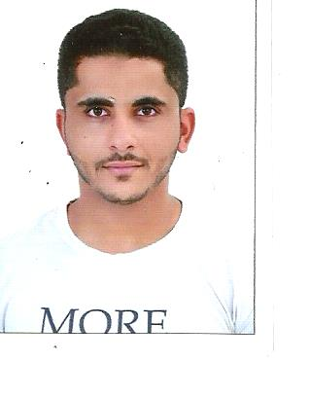

**Personal data:**

Name:Hussain A.jalil juma Mohammad ali swar

Eag:29 years old

Date of birth: 21/9/1989

C.P.R : 890911479

Nationality: Bahraini

Gender: Male

Religion: Muslim

Martial status: married

**Adress:**Flat:road6213block362Building680flat11 bilad alqadeem

**Contact:**Phone number: 36454404/33190804

Email: [hussainswar5@gmail.com](mailto:hussainswar5@gmail.com)

**Qualifications:**

* Junior certificate
* I also took my first secondary certificate only to standardiz the tracks of the year 2012 from the school of sheikh isa bin ali

**Practical experiences:**

*Free works are as follows:

* Iworked in the Central market for vegetables and Fish in jedhafs cargo carrier in 2007
* I worked with my father in the difficult task of waterproofing in 2010
* I worked in cleaning and polishing cars 2012
* I have been working in the stores of Abdullah Nas company from 2013 to this time and now I am Iooking for another job that suits as a married person

**Languages:**

Arabic: 100%

English: 40%

Indian:70%